Detecting Parkinson’s Disease Using Voice Analyzer

CSE-IT dept, 4th Year, 2018



BENGAL INSTITUTE OF TECHNOLOGY

1. No. GOVT. COLONY, BASANTI HIGHWAY, HADIA

KOLKATA-150

|  |  |
| --- | --- |
| Student Name | MAKAUT Roll No |
| Pulkit Bhansali | 12100115036 |
| Shubham Gupta | 12100115044 |
| Subhajit Dey | 12100115055 |
| Swati Jha | 12100215055 |

# Under supervision of

Sudipta Dutta

Asst. Prof,

Dept. of CSE & IT

Bengal Institute of Technology

*Approval for selection of project work and team members.*

**Signature of HOD**

---------------------------------------------

Dr. Souvik Sengupta

Head of the Department

Dept. of CSE & IT

Bengal Institute of Technology

**Date: ___05-12-2018_____________**

**Place:** ______BIT, Kolkata____________

**Signature of Mentor**

----------------------------------------------

Sudipta Dutta

Asst. Prof, Dept. of CSE & IT

Bengal Institute of Technology

**Date: ___05-12-2018___________**

**Place:** ____BIT,Kolkata_____________

# Abstract

## **Purpose:**

The purpose of the project study was to examine the effects of cognitive-linguistic deficits and respiratory physiologic changes on respiratory support for speech in PD, using two speech tasks, reading and extemporaneous speech. And early detection of Parkinson’s Disease.

## **Method:**

We are trying to do this with training set, want to form clusters with them. This going to give us separate cluster, so that if we give a new test case according to that it gives us the result of the sample voice.

## **Expecting Result:**

As the project is on examination on Parkinson’s disease so that we want to detect the disease in early stages. according to the results we can also clarify which stage the patient is.

# Introduction

Here we need to know about many things.

## **Parkinson’s Disease:**

Parkinson's disease was first described by British scientist James Parkinson in 1817 so the disease was name after him. R. Arefi Shirvan, E. Tahami [4] Parkinson’s disease (PD) is a neurological disorder that affects motor actions in human body. Major symptoms are tremors in hand, arm, legs and face, swallowing in body, speech problems, muscles rigidity, and movement problems. Though this disease occurs in aged persons yet in some cases its onset quite early. A. Benba, A. Abdelilah and A. Hammouch [2] Its onset occurs in a wide age range (45 years to 85 years). Speech problem is also a common symptom seen in Parkinson’s disease patients.

### **Effect on Voice:**

Jessica E. Huber and Meghan Darling [1] As Parkinson’s disease effects on motor organs, so it also effects on vocal muscles. Vocal muscles used for speaking, it effects on our voice too.

### Characteristics of Voice:

Vikas, R.K. Sharma [3] The speech sounds have as origins aerodynamic and acoustic phenomena. They are produced on an air flow coming from the lungs to the outside the human body. There are different mechanisms that allow the movement of an enough airflow in order to make audible the articulatory and phenomenal action.

There are Two figure describing our vocal muscles and effective organisms.

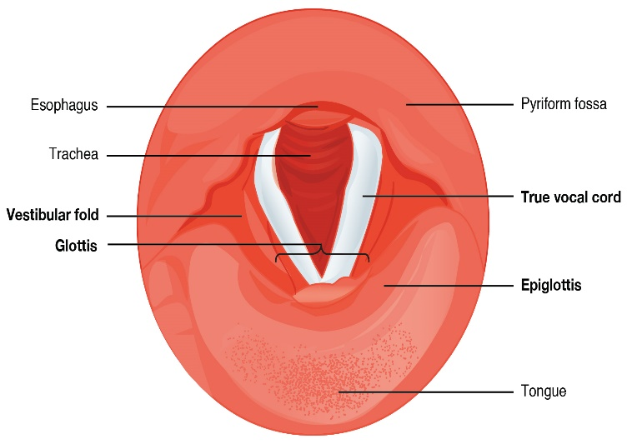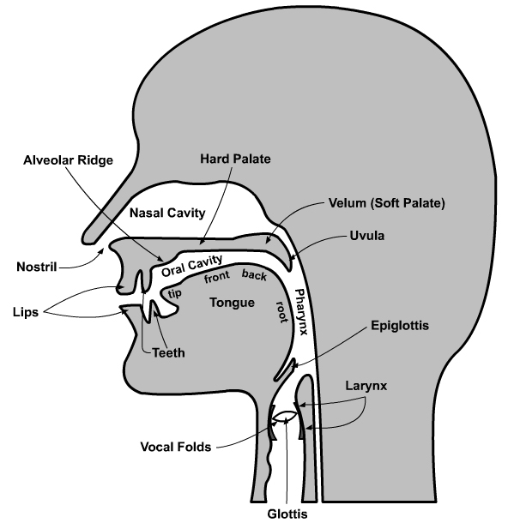

2.Cross-section of throat according to Y

1.Cross-section of throat according to X

In Parkinson’s Disease these muscles get affected, that’s why they spoke little bit differently.

## Voice Characteristics of the Patients:

The PD patients get some effects of the disease on their voice. Such as,

* In vowel interaction, patients speak in high pitch than normal people.
* Put more pressure on their throat to talk.
* React Slow in quick voice interactions.
* The voice gets louder.
* their improper vibrating leads to creation of an undesired voice

These are some side effects of PD on the patients, for which they are getting separated from normal society.

## **Audio:**

R. Arefi Shirvan, E. Tahami [4] As audio is very essential thing for us to react, it’s obvious to use it to communicate to different persons. According to previous studies on this topic we saw that 99.4% highest success rate are there by using voice in detecting Parkinson’s Disease. As any voice is a product of respiratory system and vocal system combination, so it effects on the voice very much.

We are making the audio analyser to take an average of the patient voice and normal voice.

# Objective

Our main objective is to detect PD patient in early stages. In medical there is no medicine to heal the disease, there is only very few medicines to stop the effect of Parkinson’s Disease.

Detection in early stages can stop the disease to effect more to the patient and medical scientists are trying to make medicine of the disease. As the disease first attack in CNS (Central Nervous System)it effects on the brain first.

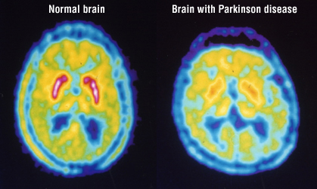

The difference between a normal brain and a PD affected brain

# Proposed Methodology

The process of the project is parted into some parts:

* Audio Analyser.
* Load the training cases in KNN algorithm.
* Getting clusters according to the graph.
* Detection.

**Audio Analyser:**

Our first thing is to take voice to our analyser and taking mean of the audio data. In this process test data sample need to say a sentence and it is going to give the pitch of the audio.

First output of audio pitch

This is the first output of the audio pitch given by the audio analyser. At first it is giving some output that comes up to down. Here actually we sectioned it into two parts and according to the parts we are getting result.

At present we are getting output of the audio with noise. So, it’s different from the normal pitch voice.

For the audio analyser part, we use library function –

* pyaudio (It doesn’t come with python package)- It input the live audio.
* Struct (It comes with python package)- It used to draw the output.
* Numpy (It doesn’t come with python package)- Used for scientific calculation.
* Matplotlib (It doesn’t come with python package)- Used to draw the graph.

**Feature Extraction:**

[3]Sound have some features like:

* Frequency.
* Amplitude.
* Time taken.

The audio analyser going to take the effective data or feature from the voice and put the feature on a graph, and according to the training cases the graph will be plotted and after that it’s going to examine by the training set.

**Load the training cases in KNN algorithm:**

### KNN Algorithm:

In easy words, if K is test set then K is who’s nearest neighbour that is to determine by this algorithm. In this we need another dataset to make the neighbours. The problem described as, if there are some cluster of points and if any individual point comes then which cluster it should join.

KNN problem example

In the figure 26 discrete points were here according to which formed 3 clusters. And now a 27th point comes and now it needs to be a part of any of the 3 clusters. Here we use KNN algorithm. According to the distances from the cluster which one is the smallest that one it should be placed. So, it might get placed in the blue cluster.

KNN algorithm also deal with fuzzy set.

Fuzzy set:

Uncertain set is an example of fuzzy set. Where we can’t say that its 0 or 1. If there is a prediction about weather today it’s going to rain or not. The weather department gives a percent of chance. Like there is 40% chance to rain. It’s an uncertain event, here is another example of fuzzy set.

0.45

0

1

55% chance to get 0 45% chance to get 1

Example of fuzzy set

**Flow chart:**

Here is a flow chart how the project will be done:

Audio Input

Audio Analyser

Feature Extraction

Frequency Analysis

Pitch Analysis

KNN algorithm & Load training set

Getting supervised/ semisupervised graph

Detection & Conclusion

Flow Chart how we want to achieve the project

There are 3 main phases of the project for us :

* Get the audio.
* Feature extraction from the audio analyser.
* Plot the feature to a graph.
* Getting result.

1. **Future Aspect**

As audio is essential things for us to communicate, and it involves several organs to work, so it also helpful to detect any disease in these organs. Audio is a product of respiratory system and sound system, so if there is any defect in lungs, we can also detect it with the use of the audio.

The audio analyser takes the pitch from the sound so in different issue we can use the analyser in anything else detection.

The list of audio detection diseases are:

* Asthma,
* Cuff and cold.
* Viral fever.
* Blood pressure.
* Heart attack also.

But as for heart attack we need to modify a lot.

We want to add some more features to the application and sell this product to any hospital or make the project globalize so that it helps normal people to take detection and prevention of some of the diseases.

We can also try other machine learning algorithms o this project to get more accurate result that help to detect the disease more accurately.

1. **Hardware & Software Used**

The current project requires following resources –

**Hardware Requirement:**

* Computer with 2GHz processor.
* 2gb RAM.
* 100GB hard disk space

**Software Requirement:**

* Any operating system(windows7+,Linux).
* Python.
* Anaconda.

1. **Reference**

* <https://www.sciencedaily.com/releases/2010/04/100419102927.htm>
* <https://www.ncbi.nlm.nih.gov/pmc/articles/PMC5609562/>
* <https://www.mayoclinic.org/diseases-conditions/parkinsons-disease/symptoms-causes/syc-20376055>
* <https://en.wikipedia.org/wiki/Voice_frequency>
* <http://code4reference.com/2012/07/tutorial-android-voice-recognition/>
* <https://www.webmd.com/parkinsons-disease/guide/parkinsons-causes>
* <https://www.everydayhealth.com/pictures/what-your-voice-may-telling-you-about-your-health/#01>
* <https://dzone.com/articles/a-tutorial-on-using-the-big-data-stack-and-machine>
* Data set collection from: https://archive.ics.uci.edu/ml/datasets/parkinsons

[1] **Effect of Parkinson's disease on the production of structured and unstructured speaking tasks: Respiratory physiologic and linguistic considerations-** Jessica E. Huber and Meghan Darling, *Journal Name-Journal of Speech Language and Hearing Research,Feb,2011.*

[2] **A Review of the Assessment Methods of Voice Disorders in the Context of Parkinson’s Disease-** A.Benba, A.Abdelilah and A.Hammouch, *journal Name-Research Laboratory on Electrical Engineering, ENSET,Dec,2016*

[3] **Early Detection of Parkinson’s disease through Voice-** Vikas, R.K. Sharma, *journal name- IEEE – International Conference on Advances in Engineering and Technology*

[4] **Voice Analysis for Detecting Parkinson’s Disease Using Genetic Algorithm and KNN Classification Method-** R. Arefi Shirvan, E. Tahami, *journal name- IEEE – International Conference on Advances in Engineering and Technology*

Thanks to Sudipta Dutta sir to help us throughout the project.